Final grant report to the Oregon Ocean Science Trust for the project:

Seafloor Mapping of Nearshore Habitats
at the Rogue River Reef Complex

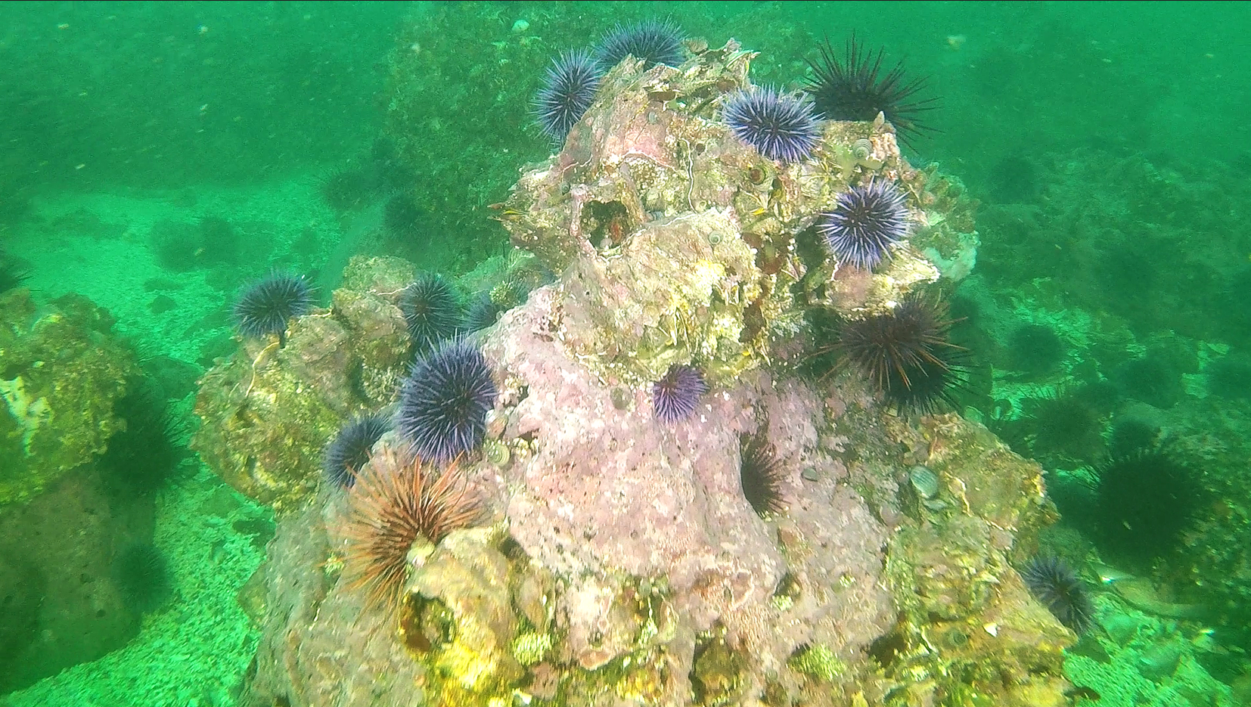

Organization:
Oregon Department of Fish and Wildlife
Marine Resources Program
2040 SE Marine Science Drive
Newport OR 97365
Phone: (541) 867-4741
Fax: (541) 867-0311
Website: www.dfw.state.or.us/MRP

Contact person:
Scott Marion
Marine Habitat Project Leader
Email: scott.r.marion@odfw.oregon.gov
Phone: (541) 819-9068
Website: www.dfw.state.or.us/MRP/habitat

Grant Period:
March 2023 – June 2025

Total funding:
$181,000
The sections below follow OOST’s requested report template (5 page limit).

a. Briefly restate the plan outlined in the original request. Were any modifications to the plan necessary? If so, please describe. What effects have modifications had?
The proposed plan was to complete a hydrographic survey to acquire detailed seafloor data for the Rogue River Reef complex, an ecologically important and under-studied nearshore region that supports a valuable red sea urchin dive fishery and is the largest remaining kelp-bearing reef in the state. The target data was high-resolution seafloor bathymetry (gridded depth data) and backscatter data (strength-of-signal data allowing interpretation of substrate characteristics). The original proposal was to contract out the work to commercial surveyors, and have the data processed by professional hydrographers. This plan was modified twice, each time with a contract revision and approval from OOST.

The first, major change was to take advantage of an opportunity presented by a new collaborator at Oregon State University, Meagan Wengrove. Dr. Wengrove owns a state-of-the-art multibeam sonar system deployable from a small vessel, and has staff with capacity to process the resulting seafloor data. Consequently, ODFW staff implemented the field surveys together with OSU staff, and OSU staff processed the data. The second, smaller change (approximately 12% of the overall budget), made possible by lower-than-expected vessel charter costs for the bathymetry data collection, was the addition of using a small remotely operated vehicle (ROV) to gather more video data documenting substrate characteristics and associated biota. In addition to the main project area, other southern Oregon sites were targeted for ROV sampling, to enhance our ability to interpret ecological patterns at Rogue Reef in comparison with other locations.

There were two main effects of the modifications. First, implementing the survey ourselves rather than contracting out the work allowed a significant increase in the shallow-water detail we were able to include, due to the cost efficiency of using our own staff and boat for that part of the work. Second, the addition of more ROV sampling puts us further along in being able to quantitatively compare seafloor ecology of the main study region at Rogue Reef with other sites that are tied to long-term studies.

b. Briefly restate the measurable outcomes as outlined in the original request. Did you achieve the intended outcomes by the conclusion of the project? What has been the effect of any changes?
The main intended outcome was the production of a high-resolution bathymetry and backscatter dataset covering all the major portions of the Rogue River Reef rocky reef complex. We achieved this goal with very high-quality data and excellent spatial coverage of many of the shallowest areas (important regions for ecological analysis and logistically difficult and time-intensive to acquire safely). The coverage includes nearby Breakers Reef, a distinct reef complex just to the north of the main Rogue Reef, and extends inshore as far as safe navigation would allow. At the deep end, the coverage followed the contour of deep-water rock substrate out as far as 70 m depths in places.

The effect of the strategic changes was that we were able to focus more mapping effort on the shallowest navigable parts of the reef, producing a more useful dataset for enabling future research on key ecological questions in nearshore communities with respect to habitats for kelp, sea urchins, sea stars, and potentially sea otters.

We were not yet able to achieve all the outreach goals of the project. In the coming months, we anticipate joining the data collected in this project together with other simultaneous ecological investigations along the south coast to focus more substantial outreach efforts on these linked investigations. Intended outreach efforts include production of at least one ArcGIS story map, social media posts, and a public seminar at Hatfield Marine Science Center.
c. What are the key findings from your project? Are your findings available online? If so, please provide the link to the website.
Key findings include documenting the distribution of shallow-water habitats that are suitable for supporting bull kelp and associated biota including sea urchins, abalone, and sea stars. We found many previously undocumented high-relief seafloor features that will be important components of future ecological studies, in terms of both research interest and operational safety. for. The seafloor data collected will allow much more effective analysis of existing and future datasets on sea urchin abundance and kelp distributions.

Interpretation of video data collected by the ROV is still underway (data extraction from video was not among the project deliverables), but preliminary observations reveal patterns in the seafloor geology that help interpret regional sea urchin abundance and kelp distribution. For example, distinguishing regions of bedrock and boulders vs. small cobbles and gravel helps explain where these species have persisted over time. Additionally, we discovered high densities of purple sea urchins in parts of the Rogue Reef where kelp has declined in recent years, confirming that urchin grazing may explain at least some component of kelp loss at Rogue Reef.

The bathymetry data and maps of the study region are available on the ODFW Data Clearinghouse at https://nrimp.dfw.state.or.us/DataClearinghouse/default.aspx?p=202&XMLname=42932.xml. Additionally, we will be coordinating with DLCD to add the data to the appropriate sites for stable, discoverable access through the Coastal Atlas. Ecological findings from ROV video (still under analysis) will be included with other investigations along the coast in an upcoming data synthesis, capitalizing on synergy with another OOST-funded grant (Rumrill/Groth sea urchin analysis project) and a USFWS-funded examination of key nearshore species along the south coast.

d. How would you best characterize the impact of your project?
The data gathered in this project will enable researchers to plan and implement efficient and safe field ecological sampling plans. Studying this reef system is important because it supports a long-productive sea urchin fishery and is one of the last substantial strongholds of bull kelp in Oregon. This project has provided depth data that are key to emerging ecological modeling frameworks, including current analyses that are being conducted for kelp distribution and potential sea otter habitat. The data support safer navigation for the boating community, while recognizing that mariners must rely on official navigation charts published by NOAA. The data will be submitted to NOAA through their External Source Data Program and will be subjected to NOAA’s quality review standards for incorporation into future production of regional high-resolution charts.

e. Lessons learned: What did you learn from the project that will advance understanding of the topic studies?
In addition to the core data described above that already allow a more informed interpretation of patterns observed in kelp distribution, and the utility of these data for future field and modeling studies, the project provided an opportunity to learn the power and efficiency of new technologies (the multibeam sonar system operated by collaborators at OSU, and the small ROV operated by ODFW) to efficiently target shallow-water research objectives. We developed a clearer understanding of the potential for future studies capitalizing on this combination of equipment and investigator knowledge to acquire seafloor data in other parts of Oregon’s nearshore environment. Specifically, there are several high-priority, kelp-bearing study regions that lack multibeam bathymetry coverage, including parts of Otter Rock Marine Reserve, one of Redfish Rocks Marine Reserve’s comparison areas at Humbug Mountain, and the rocky reef just off Cape Blanco.

f. Has this grant been instrumental in attracting additional resources in the form of people, funding, goods, services, or publicity? If so, describe.
No, not applicable.

g. How were the results of your project disseminated to the public and other communities of interest?
Scott Marion delivered a talk entitled “From the Ground Up in Oregon’s Nearshore: Seafloor Habitats, Sea Urchins, and Kelp“ at the 2024 State of the Coast conference in Seaside, OR. The talk featured a description of the Rogue Reef bathymetry work underway, acknowledged OOST funding, and included preliminary qualitative observations and connections to other work. In April 2024, the ODFWMarine account posted an Instagram story describing the project and the OOST funding. Recently we met with other researchers at ODFW and OSU who are implementing a complex trophic model assessing kelp, sea star, sea otter, and habitat interactions. Our observations from this Rogue Reef mapping project were used to support model parameterization and development.

Much of the outreach for this project is yet to come because the project’s results are intended to be integrated with data from other simultaneous studies on sea urchin and kelp abundance (still under development) for sharing broadly with the public. Specifically, our plan is to develop an ESRI ArcGIS “story map” website that will take viewers through the emerging understanding of our nearshore systems. The site will visually demonstrate the process involved with multiple aspects of our field studies (multibeam bathymetry surveys, ROV video surveys, commercial sea urchin research, kelp aerial photographic surveys), and will provide a portal to viewing the actual data acquired. The goal will be to provide a spatial and visual context that will help the general public better understand and appreciate the value of these datasets and research efforts.

h. Do you anticipate publishing the results of your project in a peer-reviewed journal?
Bathymetry datasets like this one are not typically presented in peer-reviewed journals. We are collaborating with other researchers at ODFW in preparing a manuscript that will address changes in sea star and sea urchin abundance. That publication will rely in part on the bathymetry and ROV video observations acquired in this project and will describe the funding sources for all data involved.

Requested Attachments:
Please provide the Oregon Ocean Science Trust with links to any presentations or deliverables (project websites created) so that we may share these with the public on the Trust website.
Bathymetry maps and datasets are available on ODFW’s Data Clearinghouse at https://nrimp.dfw.state.or.us/DataClearinghouse/default.aspx?p=202&XMLname=42932.xml

Please provide the Trust with up to 10 photos taken that represent implementation of your project so that the OOST may share these with the public on the Trust website. Please provide photo credits and photo captions.
Please see attached file “Marion OOST grant report - Rogue mapping photos and captions.docx”.

