Photos to accompany the OOST-funded project “Seafloor Mapping of Nearshore Habitats at the Rogue River Reef Complex.”

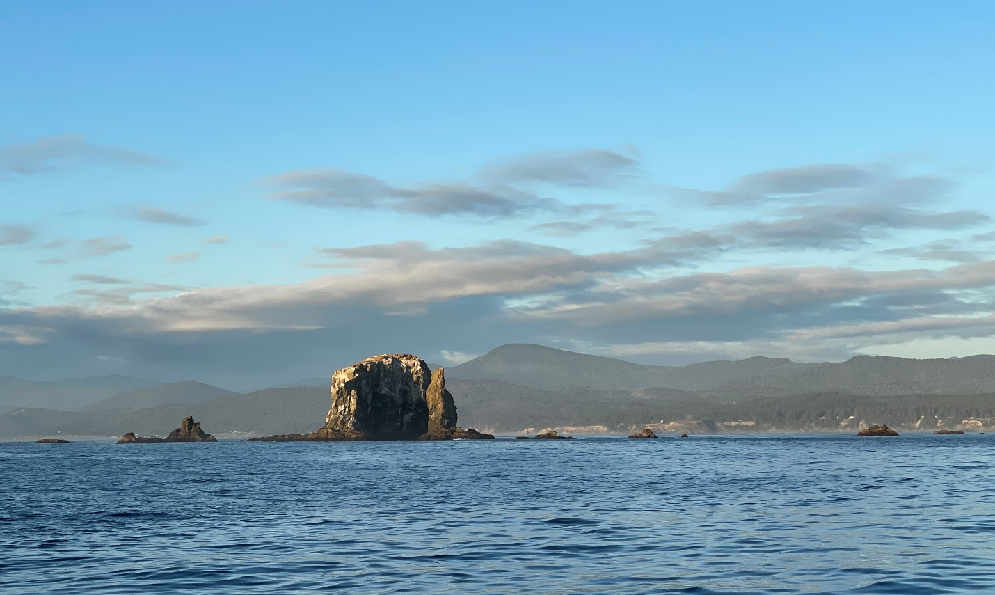
Caption: The Rogue River Reef off Gold Beach is one of the most complex regions along the coast to navigate. Abundant islands, kelp beds, and submerged “wash rocks”, combined with sparse details in navigational charts, have made navigation (and conducting ecological studies) risky and complex.

Credit: ODFW

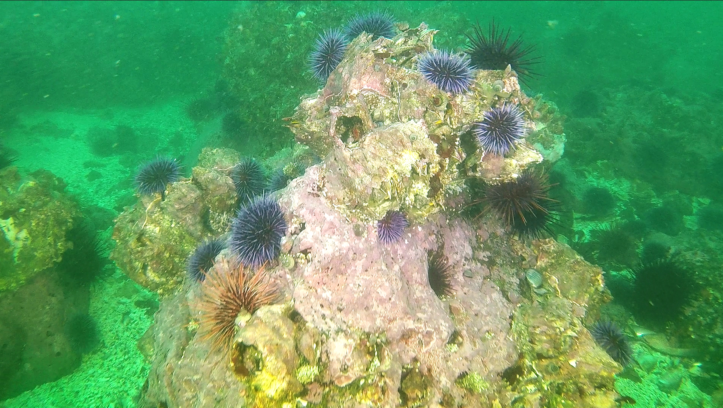

Caption: A close view of the seafloor at Rogue Reef captured by a remotely operated vehicle shows a geologically complex area and an abundance of purple sea urchins in some areas, helping to explain why bull kelp has been in decline.

Credit: ODFW

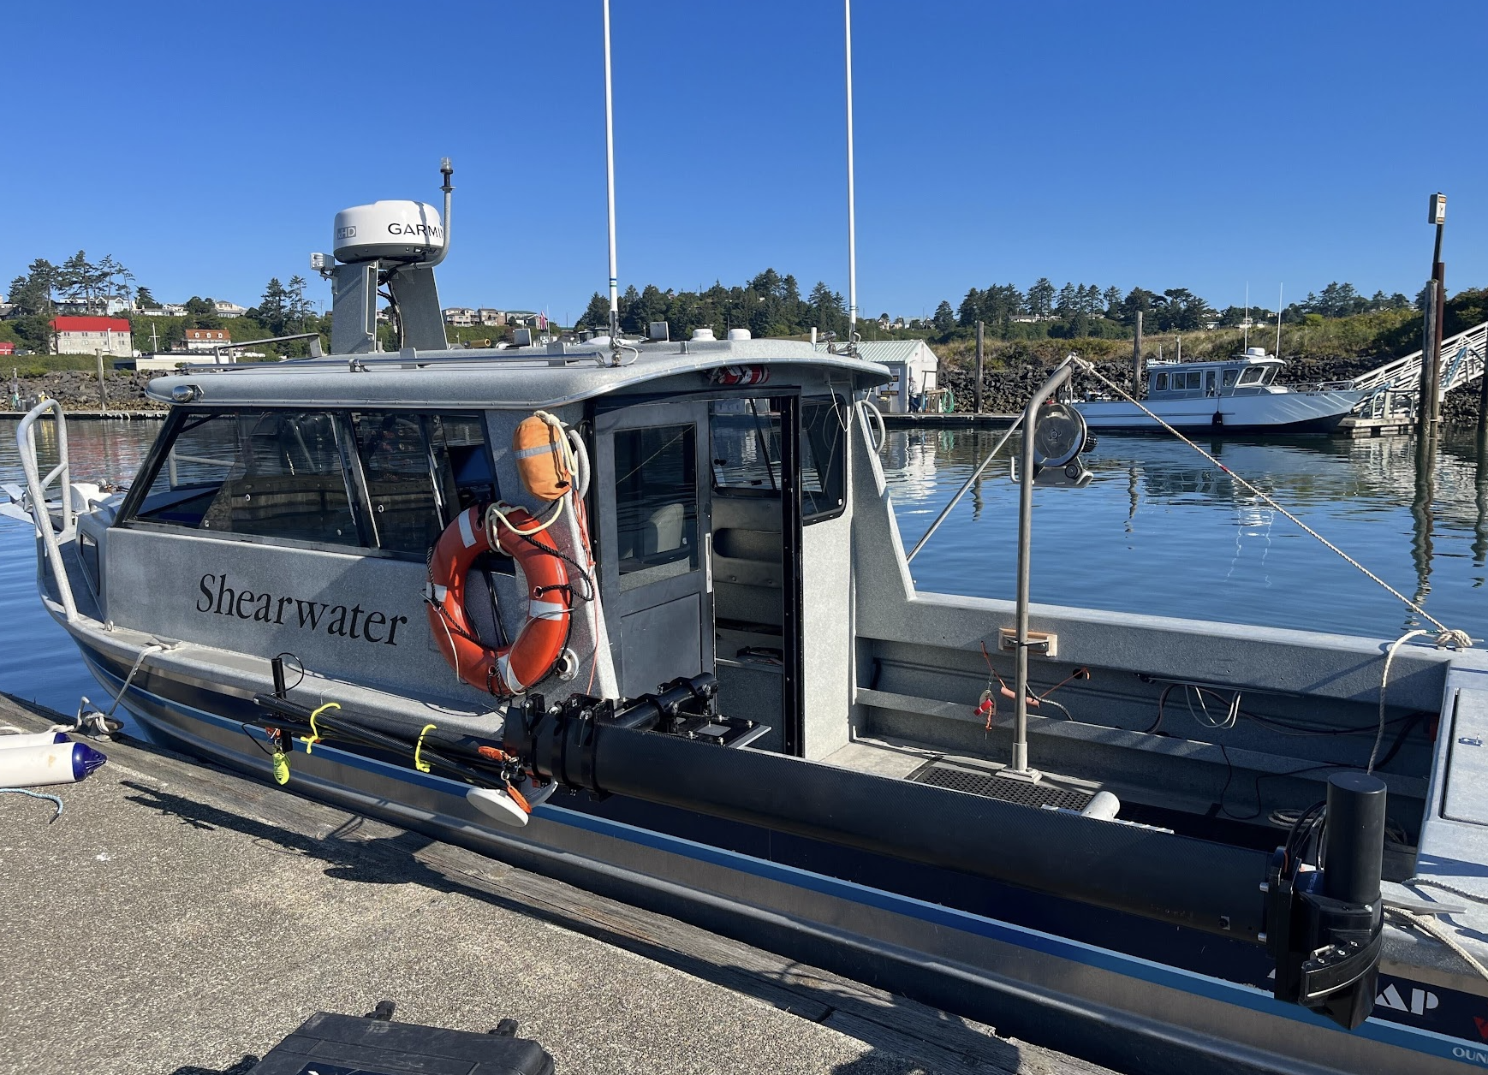

Caption: Bathymetry surveys in the shallowest parts of the reef were conducted aboard ODFW’s research vessel the R/V Shearwater, while deeper waters were mapped using a larger live-aboard charter vessel. The Norbit multibeam echosounder system used in the project (visible here mounted on a black carbon-fiber pole, rotated horizontally here for transport) has entirely integrated GPS and motion sensors, and was specifically designed to be easily transferred among vessels of opportunity.

Credit: Hannah Glover

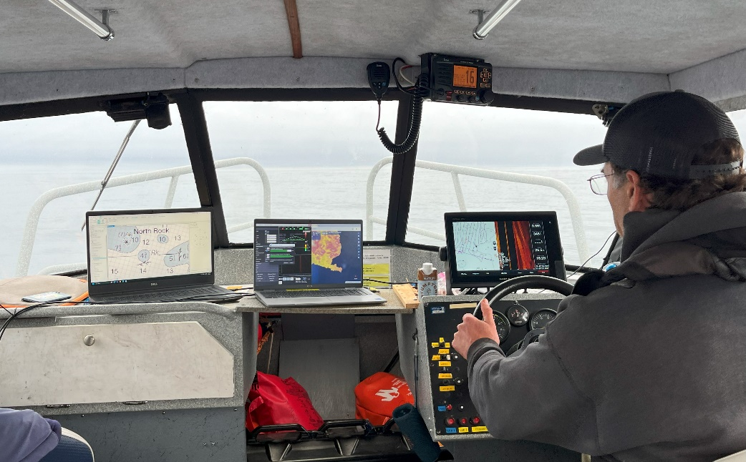

Caption: ODFW habitat biologist Scott Marion pilots the R/V Shearwater along data acquisition tracks, monitoring the real-time seafloor coverage displayed by the echosounder software.

Credit: Hannah Glover

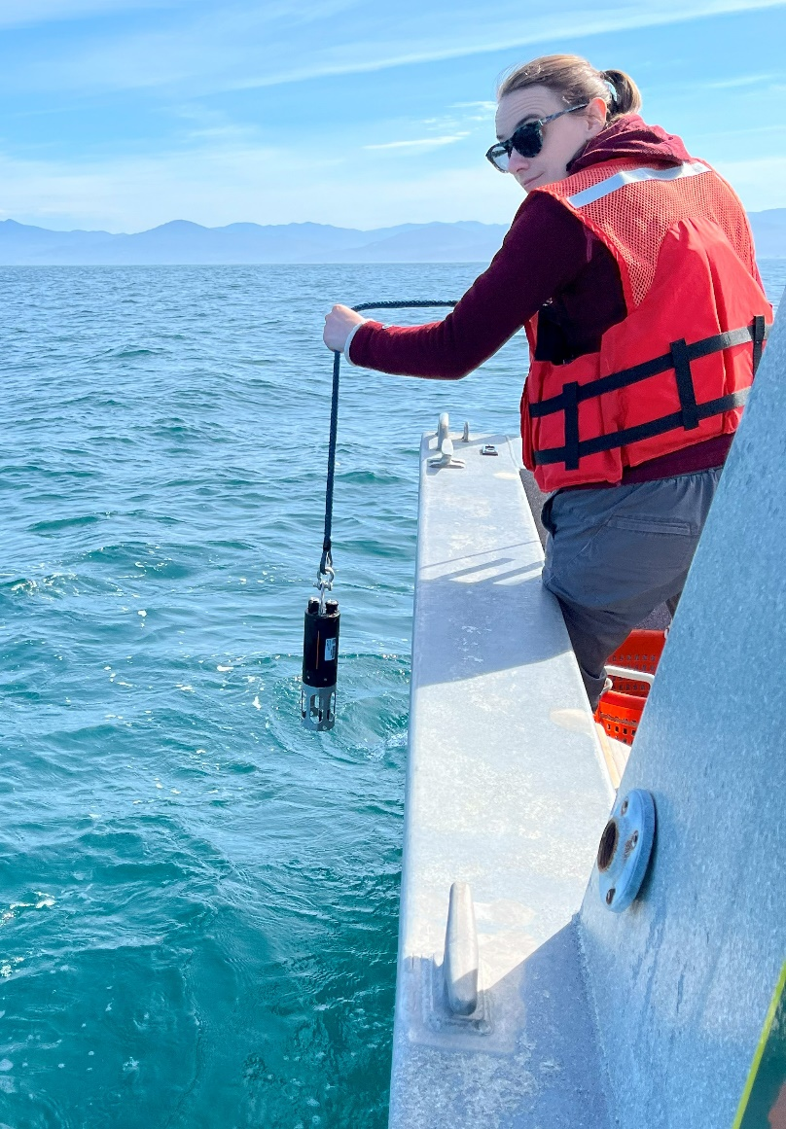

Caption: OSU scientist Hannah Glover conducts a sound velocity profile, data necessary to allow the echosounder to appropriately translate the 1,024 individual sonar signals into accurately geolocated depth readings.

Credit: ODFW

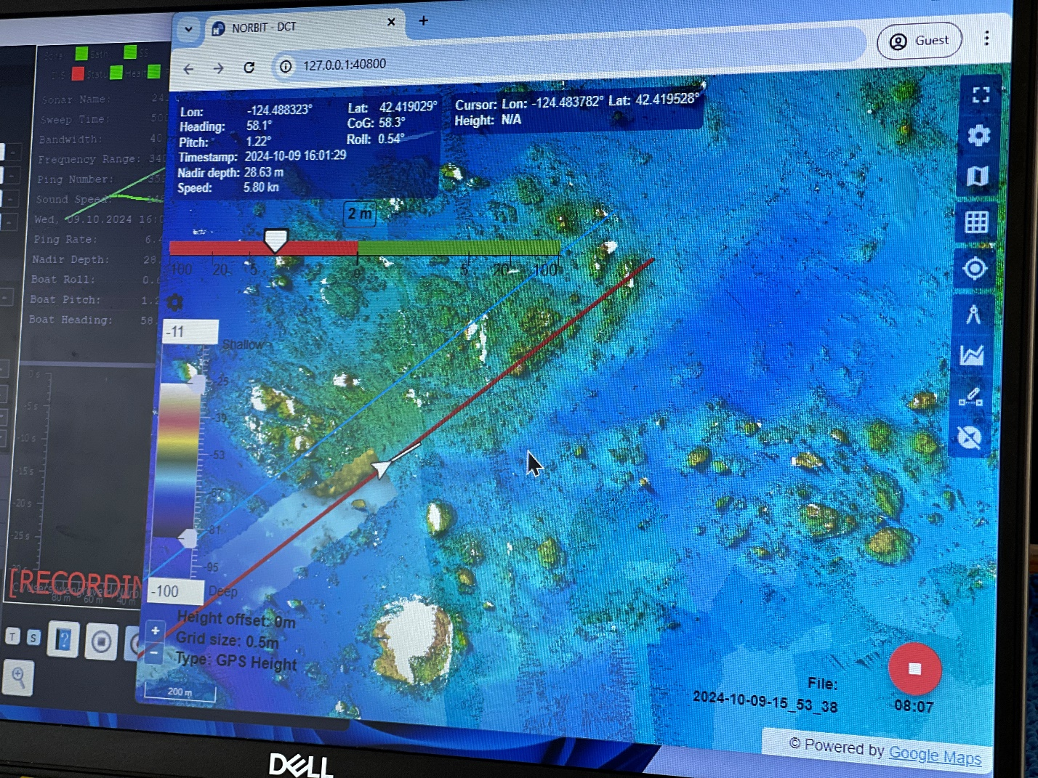

Caption: In the very complex seafloor environment presented by Rogue Reef, the echosounder’s real-time data display was critical to allowing the vessel captain to maintain good data coverage as the width of the sonar beam varied with shallow and deep waters.

Credit: Joanna Lyle
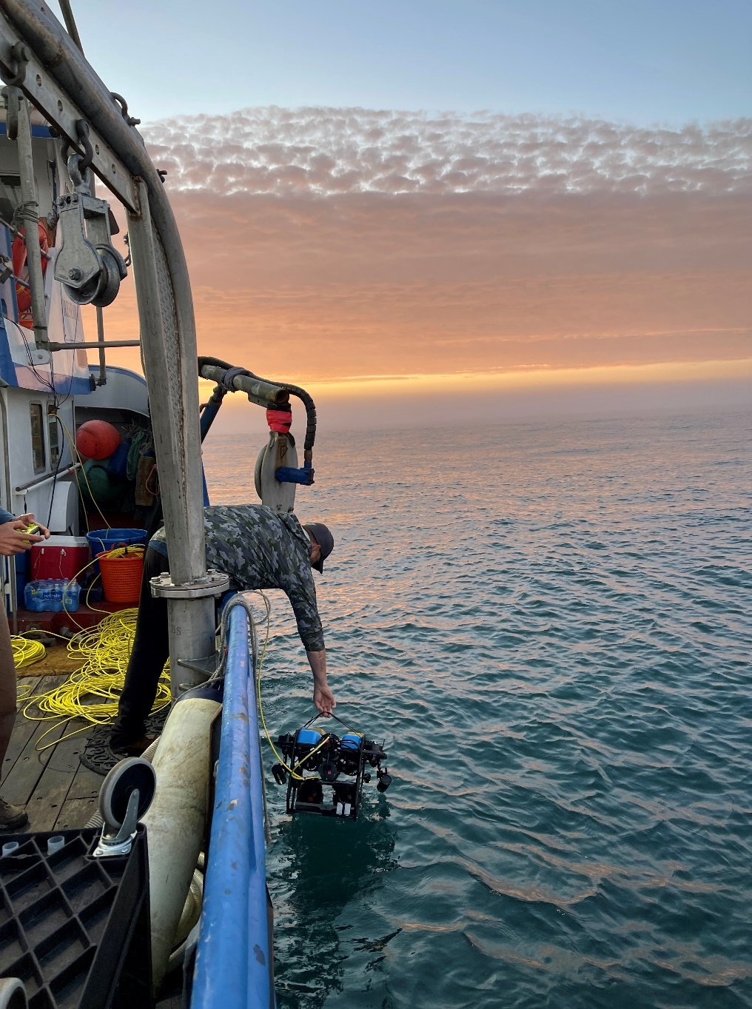

Caption: Crew aboard a charter vessel hand-deploy the small remotely operated vehicle used to gather seafloor video data.

Credit: Joanna Lyle

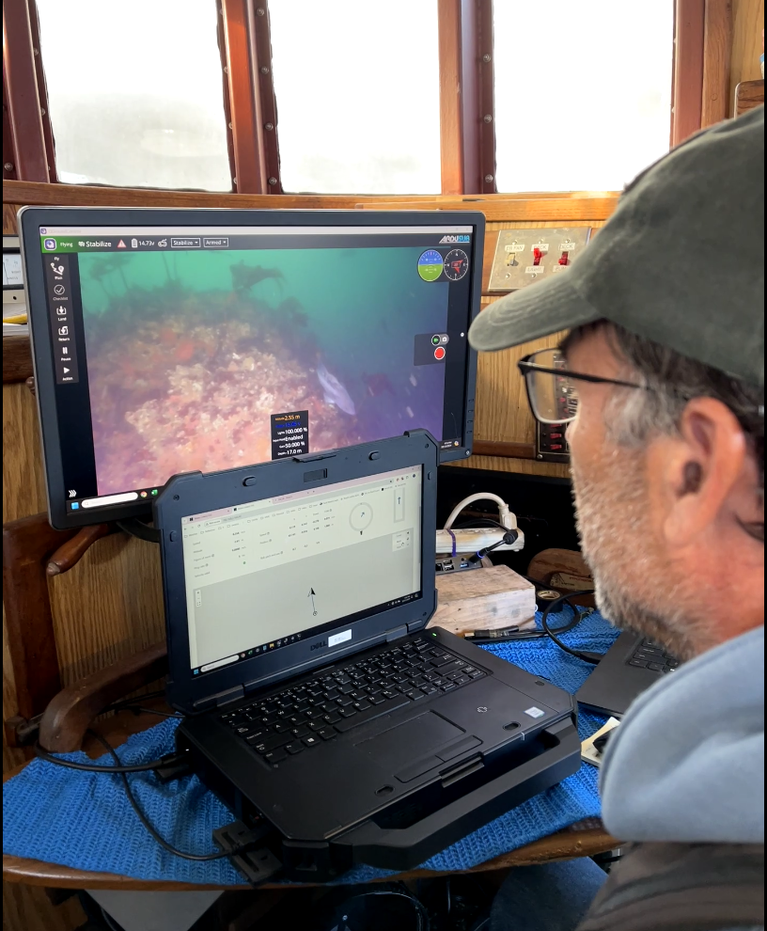

Caption: ODFW habitat biologist Scott Marion pilots the remotely operated vehicle along a seafloor transect at Rogue Reef, steering the ROV over the complex terrain with the aid of a real-time video feed and sensors aboard the vehicle.

Credit: Joanna Lyle

