Getting Started with the Wildlife Linkages Dataset

- This tutorial applies to the wildlife_linkages_shp.zip file only. Once you have downloaded the zip file, use an extraction tool to uncompress the folder and save it to a preferred location on your computer.

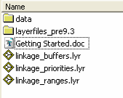
- In ArcMap or ArcCatalog, navigate to the “wildlife_linkages” folder. Inside the folder, you should see the following contents (file extensions may be missing depending on your ArcGIS settings):

- Inside the “data” folder, you will see three Shapefiles and several dBase Tables. The shapefiles contain polygon data for the linkage areas and some basic attributes. The dBase tables contain all the attribute information collected about the linkages:
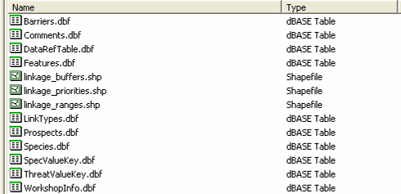

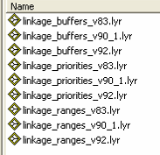
- If you are using an older version of ArcGIS, use the layer files (.lyr) in the “layerfiles_pre9.3” folder. Otherwise, for ArcGIS 9.3, use the layer files under the main “wildlife_linkages” folder.

- The layer files contain easy-to-interpret symbology for each of the shapefiles, as well as established relates that access the attribute information in the dBase tables for the “linkages_buffers” dataset.
- To look at the data in ArcMap, click Add Data , select the “linkage_buffers” layer file and click Add.

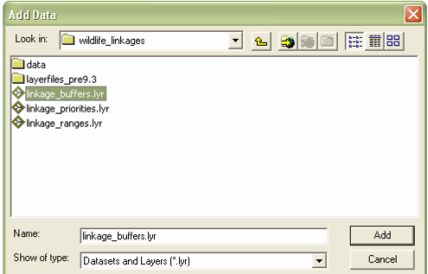

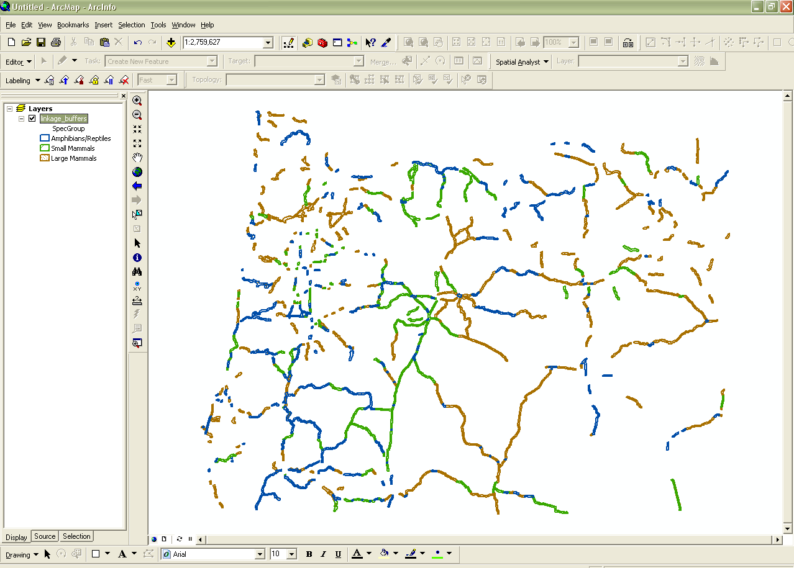
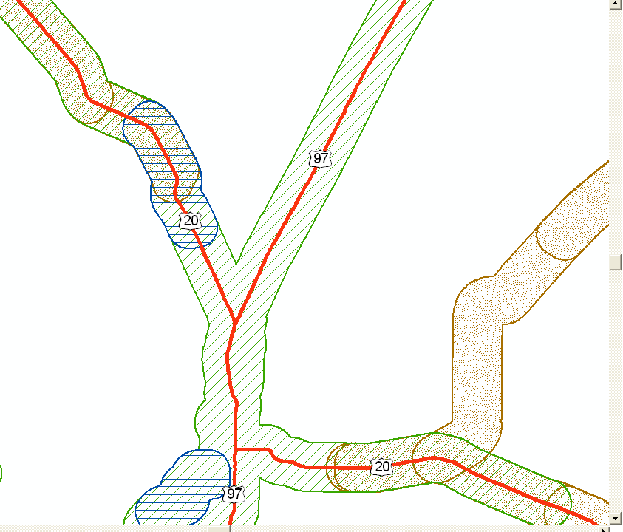
- This will add the linkage buffers layer to the map view, and you will see that the buffers are broken out by general animal type and have varying colors. Each polygon is a half-mile buffer surrounding a highway, roadway, or stream.
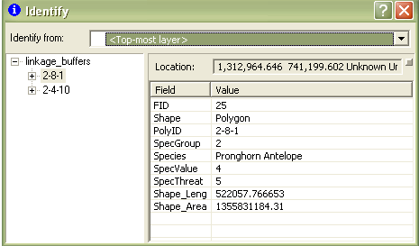
- To see attributes, use the Identify Tool and click on a linkage buffer. The left side will show you the polygon IDs for buffers that you clicked on and the right side shows you the basic attributes of that polygon. (There may be several as many linkage areas overlap)

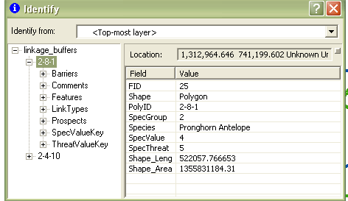
- To see attributes from the dBase tables, expand the plus sign next to the polygon ID and you will see the different attribute categories. (You may want to resize the identify window to see everything)

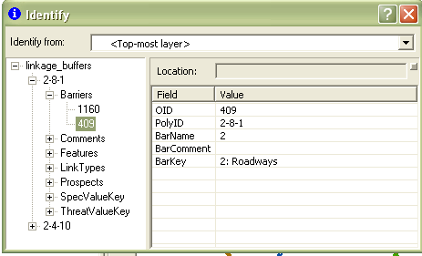
- Expand the plus signs to see the various attributes assigned under each category. Click on the number to see the information on the right side of the window.

Note: The number pulls from the OID field, which is a unique identifier ArcGIS creates to store the attribute record in the dBase table.
Click on the number to see the attribute on the right side

The OID field can be ignored.
- In some cases there may be multiple numbers under a category, meaning the linkage area meets several criteria, like the example below:
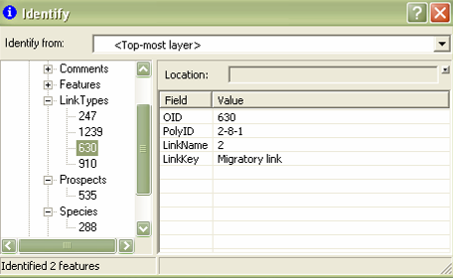

Click each number to see the different attributes under the overall category

- To see multiple attributes when working with multiple linkages, use the Selection functions and work with the Options -> Related Tables function in the “wildlife_linkages” attribute table. Please see the metadata for further explanation of the fields.

Getting Started with the Priority Linkages Dataset

- To see the linkage priorities data, click Add Data , select the “linkage_priorities” layer file and click Add.

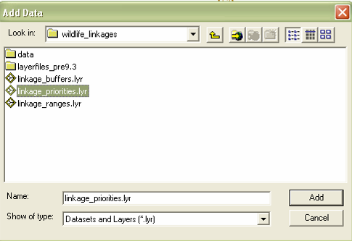
- This will add the priority linkages layer to the map view. Priority rank is determined by various criteria you can explore in the attribute table.
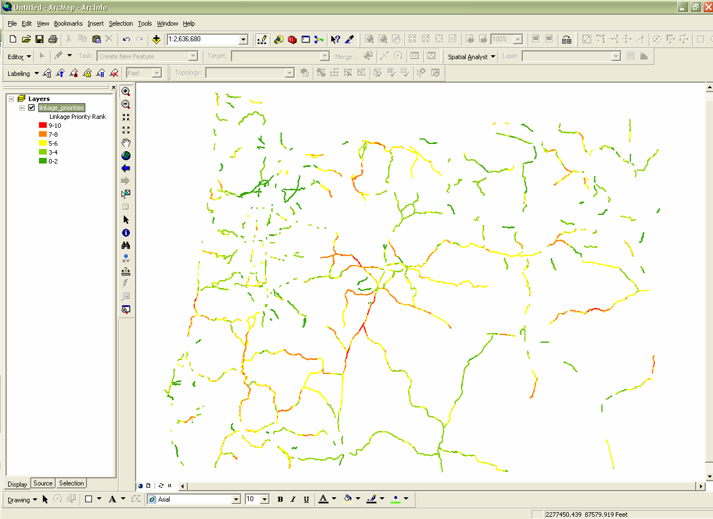
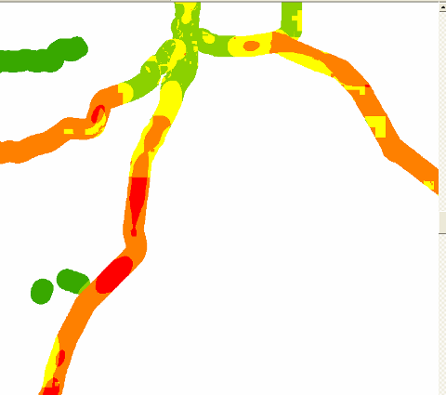

- You can use the Identify Tool to look at the attributes and see why a specific linkage section has been ranked, or you can look at the attribute table. To open the attribute table, right-click on “linkage_priorities” and click Open Attribute Table. Please see the metadata for further explanation of the fields. 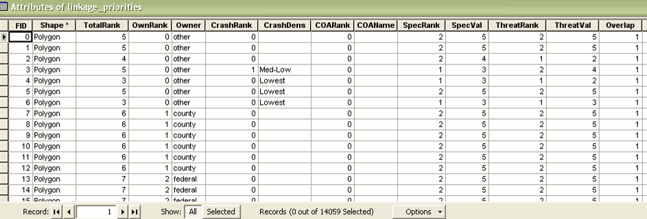

Getting Started with the Linkage Ranges Dataset

- To add the linkage ranges data, click Add Data , select the “linkage_ranges” layer file and click Add.
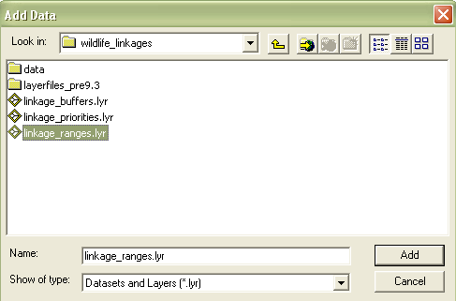

- This will add the linkage ranges layer to the map view. In some cases, areas were delineated that spanned more than just highways, roadways, and streams, so those ranges were captured. The attribute data can be accessed the same way as the “linkage_buffers” dataset (see page 3).
