PROJECT COMPLETION REPORT

STEELHEAD HABITAT SURVEYS
IN MILL CREEK
MONITORING PROJECT

OWEB PROJECT #205-125

APRIL 2007

Wasco County SWCD
2325 River Rd. Suite 3
The Dalles OR 97058

Wasco County SWCD is an equal opportunity employer.
Final Report
Steelhead Habitat Surveys in Mill Creek
Monitoring Project 205-125
Written by Wasco County Soil and Water Conservation District
For Oregon Watershed Enhancement Board
February 2007

Background
Mill Creek flows from the Mount Hood National Forest to the Columbia River at The Dalles Oregon. The creek has two major forks, which join seven miles from the mouth. The South Fork Watershed is managed by the City of The Dalles and the Mount Hood National Forest as the municipal drinking water supply. Public access is tightly regulated by the City, and forests are managed to reduce fire danger and protect water quality. Mill Creek Falls blocks fish passage 2.9 miles up the South Fork.
Mill Creek is home to Mid-Columbia steelhead, coho salmon, Chinook salmon and cutthroat trout. Cutthroat are found in the South Fork and its tributaries above Mill Creek Falls. Steelhead migrate up to Mill Creek Falls in the South Fork. On the North Fork, they migrate up 6.5 miles to a point on the Mount Hood National Forest. All told, steelhead utilize about 18 miles of stream in the Mill Creek watershed. Coho and Chinook utilize some 7 miles in the mainstem. The coho and Chinook are both believed to be hatchery strays, rather than a native run.
NOAA Fisheries identifies steelhead in Mill Creek and neighboring Fifteenmile Creek as a single population. No hatchery steelhead have ever been released in either stream. Fifteenmile and Mill Creek are home to the easternmost population of wild winter steelhead in the Columbia Basin. They represent the edge of the range for the winter-run life history. Their genetic material is therefore valuable for the long-term survival of the species.
NOAA Fisheries considers 500 returning adults to be the minimum size population to prevent genetic drift. In the 1990s, estimates of returning adults in Fifteenmile Creek ranged as low as 130. Considering the extremely depressed levels of the Fifteenmile steelhead population, the Mill Creek component of this run may be very important to the genetic integrity of the overall population.
The Dalles Watershed Assessment identifies several potential ecological issues affecting water quality and fish habitat in Mill Creek. These issues included suppression of riparian vegetation, incised channels, summer water temperature, urban storm runoff, water withdrawals, pesticides, and partial fish passage barriers. Summer water temperatures, although exceeding the state biological criteria, are lower than in lower Fifteenmile Creek.

Prior Existing Monitoring Efforts
Mill Creek was monitored for temperature and pesticide contamination from 2002 to 2004. In every year, malathion and chlorpyrifos were found in the mainstem of Mill Creek at levels above the state standard for chronic exposure.
The City of The Dalles monitors flow and drinking water quality parameters at its intake on the South Fork.

Existing Restoration Efforts
Orchardists, with the assistance of the WyEast Resource Conservation and Development Council, are addressing pesticides and riparian vegetation through the IFPnet Project. A network of 57 weather stations has been installed throughout the northern part of Wasco County. This network collects information on wind conditions, temperature, dewpoint, and precipitation, and makes it available via the internet (www.ifpnet.com). Orchardists use this information to fine-tune their practices to reduce broad-spectrum pesticides, reduce spray drift, and improve irrigation efficiency.
The City of The Dalles has a policy of promptly addressing fish passage barriers created by its drinking water pipeline, as these barriers are identified or are created by streambed scour.

Statement of Need for This Project
The fish populations of Mill Creek have been studied only minimally. The Mount Hood National Forest has two years worth of steelhead redd counts on the public portion (two miles of anadromous habitat) of North Fork Mill Creek. Habitat conditions have not been systematically surveyed in the mainstem or either fork.

Description of the Project
This project added to the existing information about steelhead in Mill Creek in the following ways:
- Oregon Department of Fish and Wildlife completed an instream habitat inventory from the mouth to the forks, up the South Fork to Mill Creek Falls, where anadromy ends, and up the North Fork for the first 7,370 meters.
- Oregon Department of Fish and Wildlife conducted steelhead redd surveys in the mainstem and South Fork in 2005 and 2006, while the US Forest Service conducted redd surveys in the federally-owned upper reaches of the North Fork.
- Wasco County Soil and Water Conservation District installed depth and temperature monitors on the mainstem and North Fork, while relying on the City of The Dalles to monitor flows in the South Fork.
The purpose of these efforts was to provide critical information regarding the carrying capacity for steelhead and utilization by steelhead of the Mill Creek watershed, as well as to identify any limiting factors that could be addressed through restoration efforts.

Volunteer Participation
This project has involved no individual volunteers.

Other Participants
The following organizations have taken part in this project:
- Wasco County Soil and Water Conservation District—project leadership, fiscal administration, and flow monitoring.
- Oregon Department of Fish and Wildlife—habitat inventory and steelhead redd surveys.
- US Forest Service—Redd Surveys on Upper North Fork.
- City of The Dalles—Providing flow and temperature data from South Fork
- Wy’East Resource Conservation and Development Board—installation and maintenance of flow/temperature stations.

Materials and Methods Used

Habitat Surveys
The ODFW Aquatic Habitat Inventory was used to survey for fish habitat on Mill Creek for the following reasons:
- It is comprehensive;
- It allows comparison of conditions in Mill Creek to those in neighboring Fifteenmile Watershed and other watersheds in Wasco County;
- It is an inventory of conditions without value judgment;
- It is accepted and understood by ODFW.

Flow and Temperature Monitoring
The City of The Dalles monitors flow on South Fork Mill Creek. Therefore, it was considered necessary only to monitor flow on North Fork and on the mainstem. Two stations were installed. At these sites is a “Level-Watch+T” sensor buried in the stream bed that measures the stream temperature and the pressure (depth in feet) of the water above it. These sensors are hooked up to radio transmitters, as part of the IFPnet operated and maintained by Wy’East Resource Conservation and Development Board. Data can be downloaded off the internet by visiting http://www.ifpnet.com. In addition, a relay station had to be installed on the ridgeline overlooking the North Fork stream monitoring site.
Because the sensors are giving stream level instead of flow, personnel from Wasco County SWCD periodically go out to the sites to take stream flow readings, which are correlated with depth readings from the IFPnet. Flow readings are collected using a hand held flow sensor mounted on a wading rod. Water velocity and depth are measured at regular intervals across the stream, and flow is calculated as the addition of the flows in each interval. Theoretically, with enough of these readings, a conversion chart can be developed and flow estimated at any depth.

Redd Surveys
ODFW conducted redd surveys in 2005 and 2006 on the mainstem of Mill Creek and on the South Fork up to the Wick’s Water Treatment Plant. A redd is the site where a steelhead or other fish buries its eggs in the sediment. Therefore, redd surveys provide an index of the spawning population. Two fish biologists begin walking in the stream, going either upstream or downstream, and record every redd they see, noting its location, and also taking note of any living fish or carcasses they see near by. Redds are most visible when they have just been built, so timing of the redd survey is important.
The US Forest Service began conducting redd surveys on the federally own portion of North Fork Mill Creek in 2002. This year (2007), they plan to add three miles of privately owned stream to their survey reach as well.
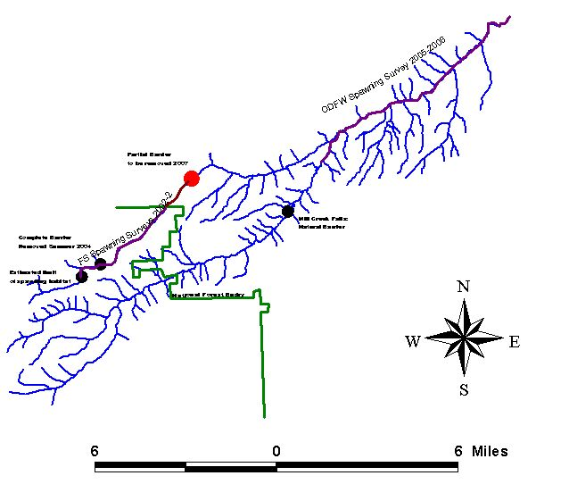

Evaluating Strengths and Weaknesses of Project Methods, Materials and Assumptions

Results Shown or Expected

Habitat maps
The Aquatic Inventory produced by ODFW is a long, detailed document with little or no interpretation in it, just data. Therefore, Jennifer Clark produced a series of maps that summarized the data graphically and interpreted them according to ODFW benchmark values. In each of the following maps, the width of the stream channel indicates greater or lesser values for the habitat parameters, whereas the color, blue versus red, indicates desirable versus undesirable values, respectively.
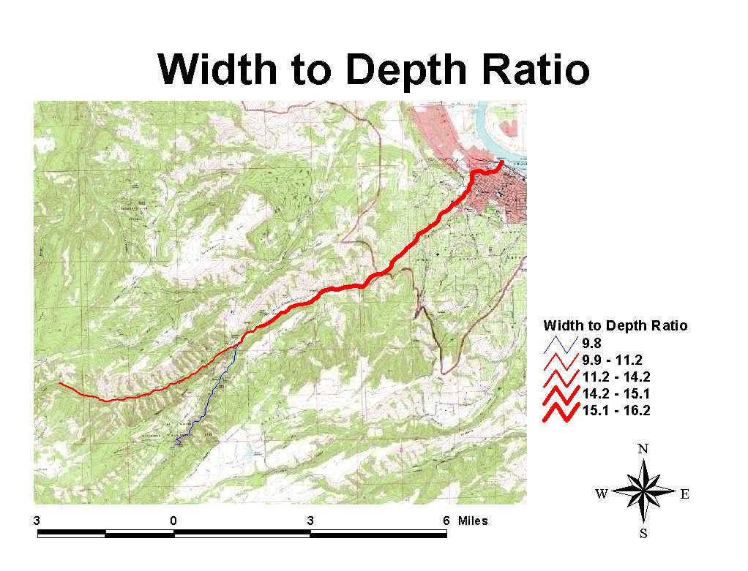
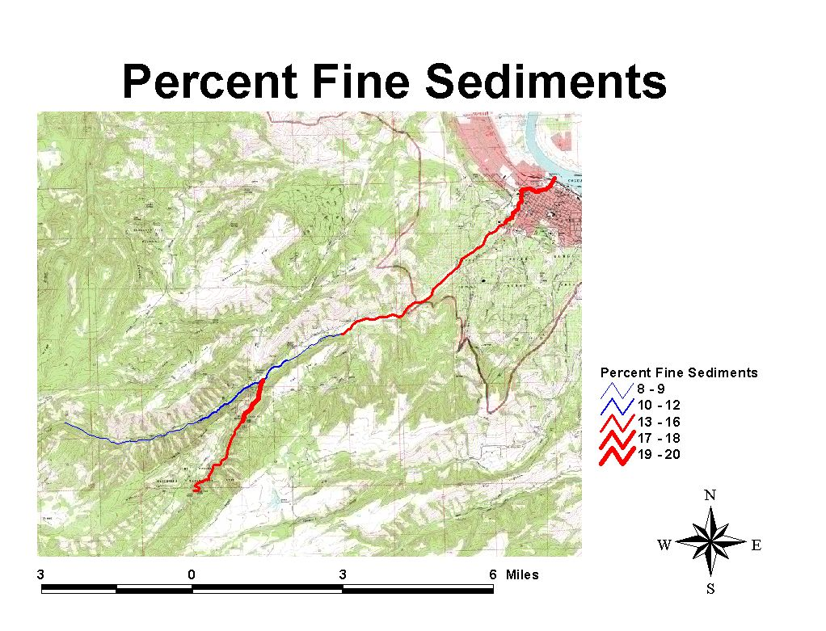
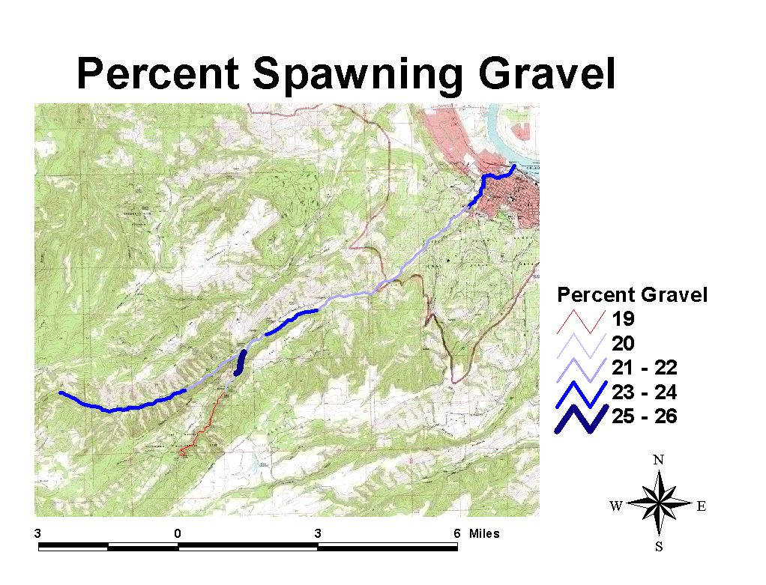
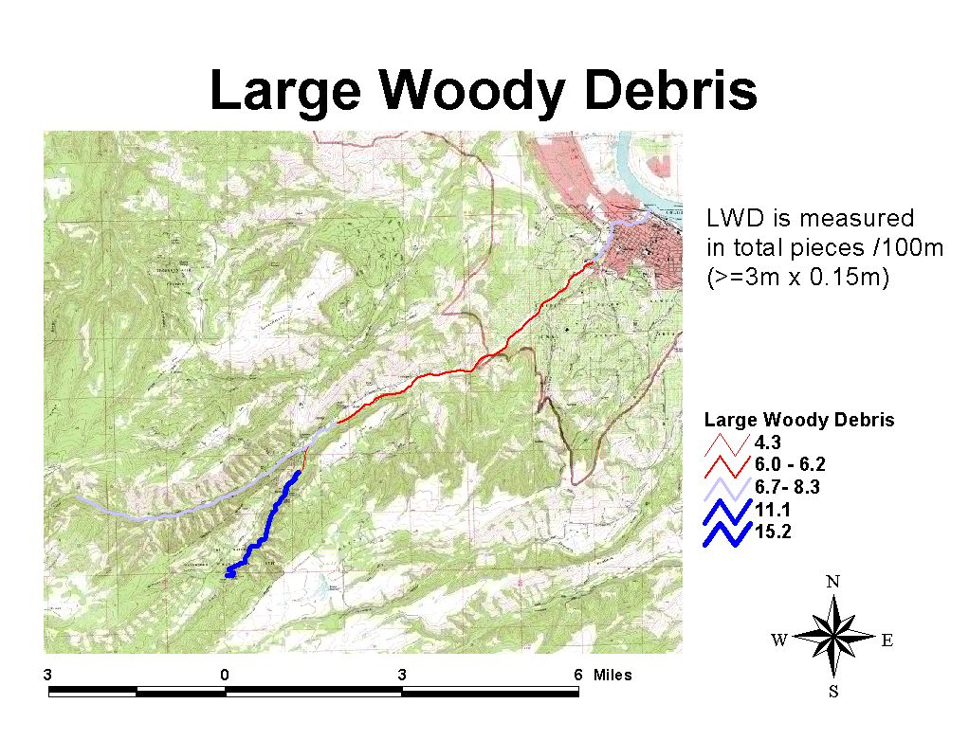
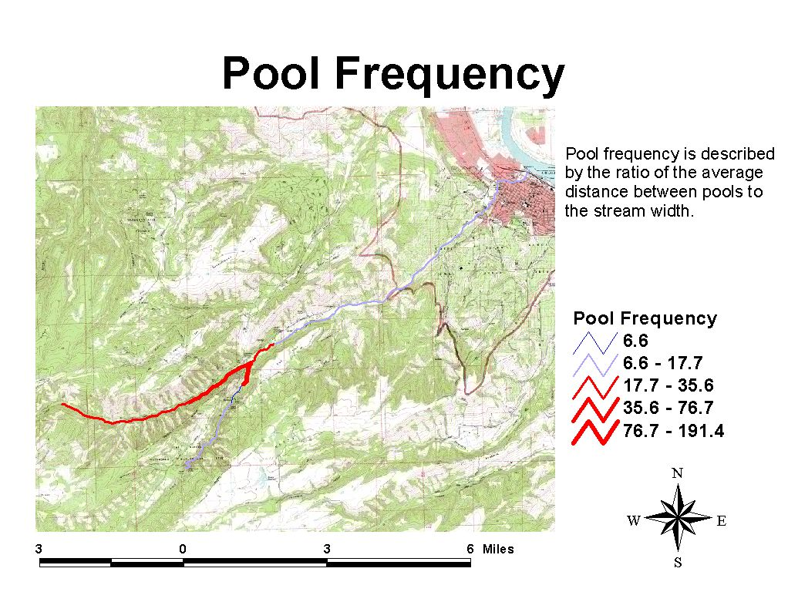
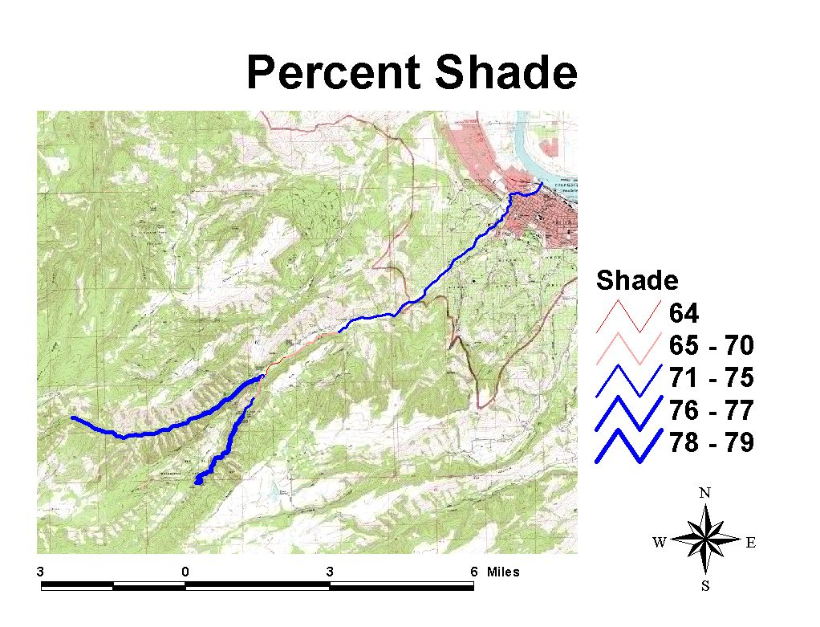

Stream Gage Readings
The following three charts show stream gage readings for the mainstem and North Fork and flow readings on the South Fork for Winter 2005-2006. Flow on the South Fork was provided by the City of The Dalles and was measured at the Wick’s Water Treatment Plant, where the City collects its water. Stream gage readings on the North Fork and the mainstem were collected by the gaging stations installed by this grant.

The following charts show stream gage readings for winter 2006-2007. We do not have the necessary data to convert these readings to flow, however, based on readings taken on January 30th, 2007, a reading of 0.93 feet on North Fork corresponded to a flow of about 14 cfs. The same day on the mainstem, a reading of 0.45 feet corresponded to a flow of 45 cfs. This is in keeping with a rule of thumb reported by the City of The Dalles watershed manager that South Fork typically contributes twice as much flow as North Fork.

Limitations on Method and Results: Flow Monitoring
Measuring flow has been a process of trial and error. Level sensors were first installed in August 2005. These sensors washed out in the high flow event of December 30th, 2005, thus rendering useless all depth readings collected after that. Sensors were buried deeper in the sediment in August 2006, and collected valid data throughout the winter of 2006/2007.
Difficulties were also encountered in converting these readings to flow. In order to create a conversion table, flow measurements must be collected by an individual who enters and wades the creek. This technique is not safe at flows above about 40 cfs, thus preventing the development of a conversion table that is valid at typical winter flows.
Because of these technical difficulties, as well as instrument breakdowns with the hand-held flow measurement devices, Wasco County SWCD has yet to develop a depth-to-flow conversion table for Mill Creek or North Fork Mill Creek.
To avoid such difficulties, Wasco County SWCD recommends using an infrared flow sensor instead of a level sensor. A flow sensor measures stream depth and velocity at the same time. The stream cross-section is programmed into the sensor, thus allowing it to continuously estimate flow. The flow sensor is significantly more expensive to purchase, but eliminates the necessity of a human technician physically entering the stream to measure flow.

Stream Temperature Readings

Limitations on Method and Results: Temperature Monitoring
Temperature readings after December 22, 2006 were invalid on the mainstem. Temperatures shoot up suddenly and then gradually drop. We believe that water may have gotten into the conduit in which the sensors are housed. This is somehow causing fallacious readings. This problem will be addressed in the summer, when the equipment will be disassembled, dried out and reinstalled with precautions to prevent the entry of water.

Redd surveys
Summary of results, Mill Creek Redd Surveys, 2002-2006
 | ODFW (Mainstem and Lower South Fork—8 miles) | USFS (Upper North Fork—2.1 miles in 2002, 2.9 miles in 2003, 2004 and 2006, and 3.9 miles in 2005)
2002 | -- | 5
2003 | -- | 3
2004 | -- | 4
2005 | 37 | 11
2006 | 12-14 | 1

Limitations on Method and Results: Redd Surveys
Redd surveys have not been collected on South Fork above the Wick’s Water Treatment Plant or on North Fork below the Forest Service Boundary. In the case of the South Fork, high flows made it difficult and/or unsafe for biologists to enter the stream and see the redds above the city water intake. It is believed that this reach may be one of the major spawning areas in the Mill Creek Watershed. Jason Seals, ODFW Assistant District Fish Biologist in The Dalles agrees: “I believe we had good passage over the Wick's diversion last year (2006), which lead to fewer redds below the diversion, and more above the diversion which we couldn't count.” (Jason Seals, e-mail, 2/16/07) A solution has not yet been found to this problem. Video monitoring of the fish ladder at the Wick’s Water intake was considered, but eventually rejected, as fish do not exclusively use the ladder during spring flows. During spring flows, a high percentage of fish jump the dam.
In the case of the North Fork, ODFW fish biologists chose not to survey the private lands due to uncertain relations with the landowners. Because there is known spawning both above and below this reach, it is believed that this reach may also be a productive spawning area. For 2007, The Dalles Area Watershed Council coordinator made an outreach effort to some of these landowners in an attempt to fill in some of this data gap above the uncooperative landowners by having the Forest Service expand their survey reach downstream. All four landowners contacted were cooperative, however budget cuts at the Forest Service may force them to cancel all redd surveys on the North Fork in 2007.
Thus, redd surveys were not collected in fully half of the watershed believed to be productive for spawning. This is a major limitation on the value of the data collected to date.

Final Accounting

Contributions to the project included the following:
OWEB cash $24,191.53 (69.8%)
Wasco SWCD cash $ 1,027.54
TD WSC in-kind $ 1,500.00
ODFW in-kind $ 1,920.00
USFS in-kind $ 5,760.00
City of TD in-kind $ 240.00
TOTAL $34,639.07

Match Form attached.

